Aaron Su

Caelen Coe

Noah Whelan

Mahamed Dirie

Rhea Chen

Valentina Valero

# **Design Concept**

### **Design Requirements**

The project will be a bluetooth-driven, stair-climbing robot. The robot will be capable of climbing stairs of which each step is 5 inches tall and 12 inches long through a multi-wheeled design. The robot will also have to pull up a 1.5-kilogram weight, making the design of the robot light and sturdy but also requiring independently driven wheels. Finally, the robot will have to have its own power source and Arduino in order to be controlled over bluetooth.

**User Interface**

The main users of the project will be staffs or drivers who will control the robot to travel to a desired destination, either with or without cargos. Our users are intended to have similar skill and ability as actual users of a commercial stair-climbing robot, such as security officials, military officers, or professional movers. Considering our users’ diverse cognitive affordances, such as language, and education background, we will implement our user interface on either a tablet or on a remote controller, with buttons labeled with universal symbols and colored in shared convention (Figure 1, see page 7).

There will be a direct screen interface on the application of the robot as well as a direct non-screen interface on the robot. The “power” switch will be both on the robot and on the application and will function as the regular and emergency stop button to cut power to all robot systems. The “power” switch control will be in passive mode: it requires user input to turn on and turn off the power. The application will provide further interaction with the robot as it provides direction buttons that take inputs from users. The robot will also take a series of implicit inputs as default values including the surface mode (flat, incline, or stairs) and the weight of the robot. The direction switch will be in active modes: if the user doesn’t press any direction, the robot will not move.

Several of the indirect interfaces include lights to indicate if the robot is loaded with cargo and to indicate if the robot is in “drive” mode. The constraints of the robot include the restriction on movement if the robot is overweight or if the robot is not in drive mode.

### **System Environment**

The complexity of stair‐climbing involves more than climbing over an obstacle or going up a slope. For this reason, it is important to take into account the environment in which the system will be operating. The system is expected to operate in a flight of stairs by being able to climb steps one at a time. The location will be Maple Hall in the University of Washington. Each step will have a height of 5⅝ inches, and the stairs will vary in characteristics such as the material and whether or not it is a backed stair. There will also be external entities that may interact with the system such as the weight that the stair climbing robot will be carrying, which will be approximately 1.5 kg.

Since the environment in which the system is expected to operate may vary greatly, this will affect the functionality of the robot. A backless stair means that as the robot moves up the flight of stairs, it can fall through the gap while in the process of moving from one step to another. This means that the robot will have to have a large chassis and large wheels to avoid falling through. Also, the different materials of the stairs may affect the mobility of the robot, with surfaces such as carpeted stairs producing more friction with the wheels. This means the wheel design has to be versatile in order to be slicker on rough surfaces and grippy on smooth surfaces.

In terms of external factors to the stairs, people walking up or down the stairs can impede the robot’s movement. In addition, if the robot were to drive outdoors, precipitation or wind can also cause problems for the robot’s stair traversal. Currently the robot is only intended to be driven indoors, but an outdoor modification for the robot would include shielding for the electronics and sensors to detect for people.

### **System Input/Output**

Figure 2 details how the robot will process different bluetooth commands it will be given. The commands will be a variety of driving instructions that can cause the robot to go in four different direction; forward, backward, to the left and forward, and to the right and forward. The Arduino on board of the robot will interpret each command and power the motors in the commanded way.

The direct processes occurring on the Arduino will be certain motor operations given to each of the independently powered wheels. This will include instructions for the number of rotations each motor needs to make (given in units of seconds) and a direction (a boolean value for forward if true and backwards for false). In the case of all wheels given a time and positive boolean, the robot will drive forward. In the same case but a negative boolean, the robot will drive backward. In the case only the right wheels are told to drive, the robot will turn right. In the case only the left wheels are told to drive, the robot will turn left.

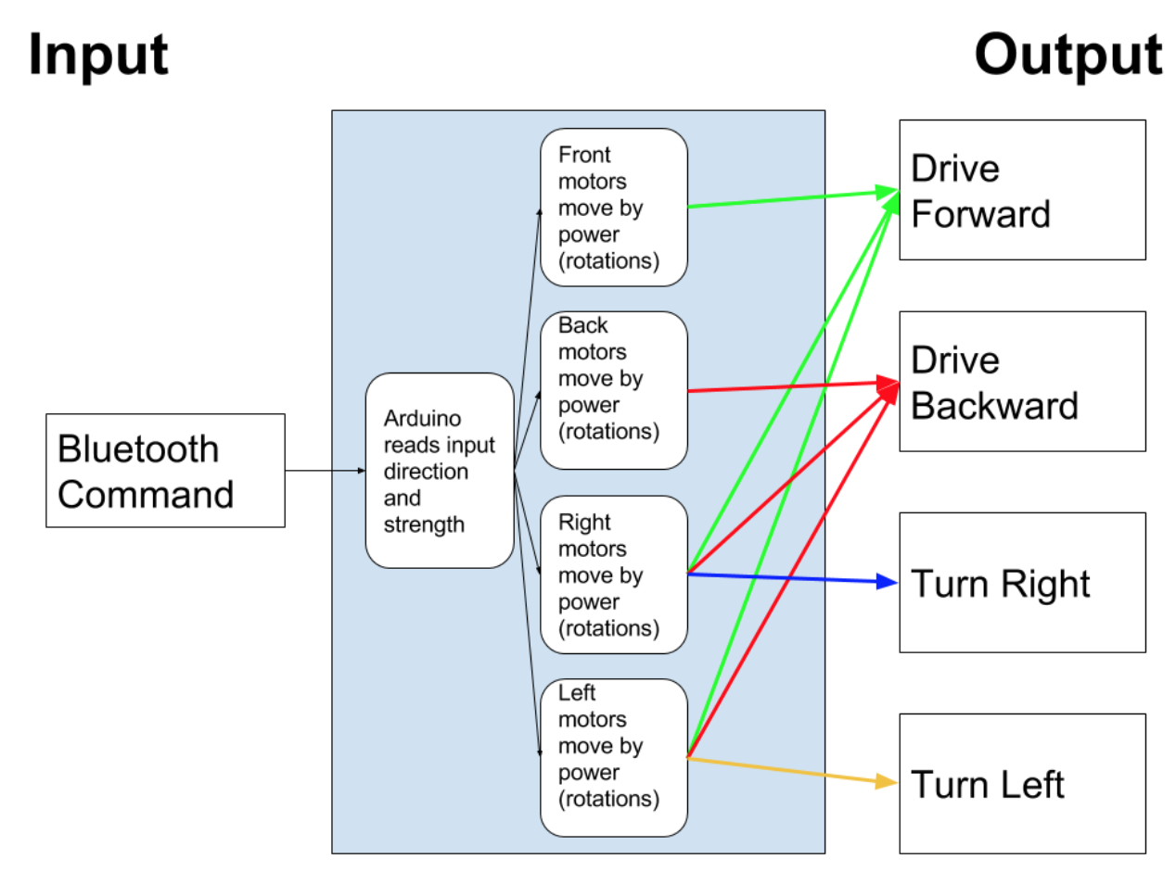

Figure 2: I/O Diagram

### **Concept Sketches**

### 

Figure 3: Concept Sketches - 1

### 

Figure 4: Concept Sketches – 2

### **Preliminary Technical Drawing**

# https://lh6.googleusercontent.com/6Tep2OiNSI0dlVSXTc0I3rU3jCqVPFwg4ZxSsRtfK1YlQLcJueCxBdBE18YdvgjCQkRnqNK5kTLVCNS9n9I4fkPysSHaYldsm_j8pg5WN6jB8MVNZ_SmP6FzWMgMAXG9mAYVEQOO

Figure 5: Preliminary Technical Drawing – 1

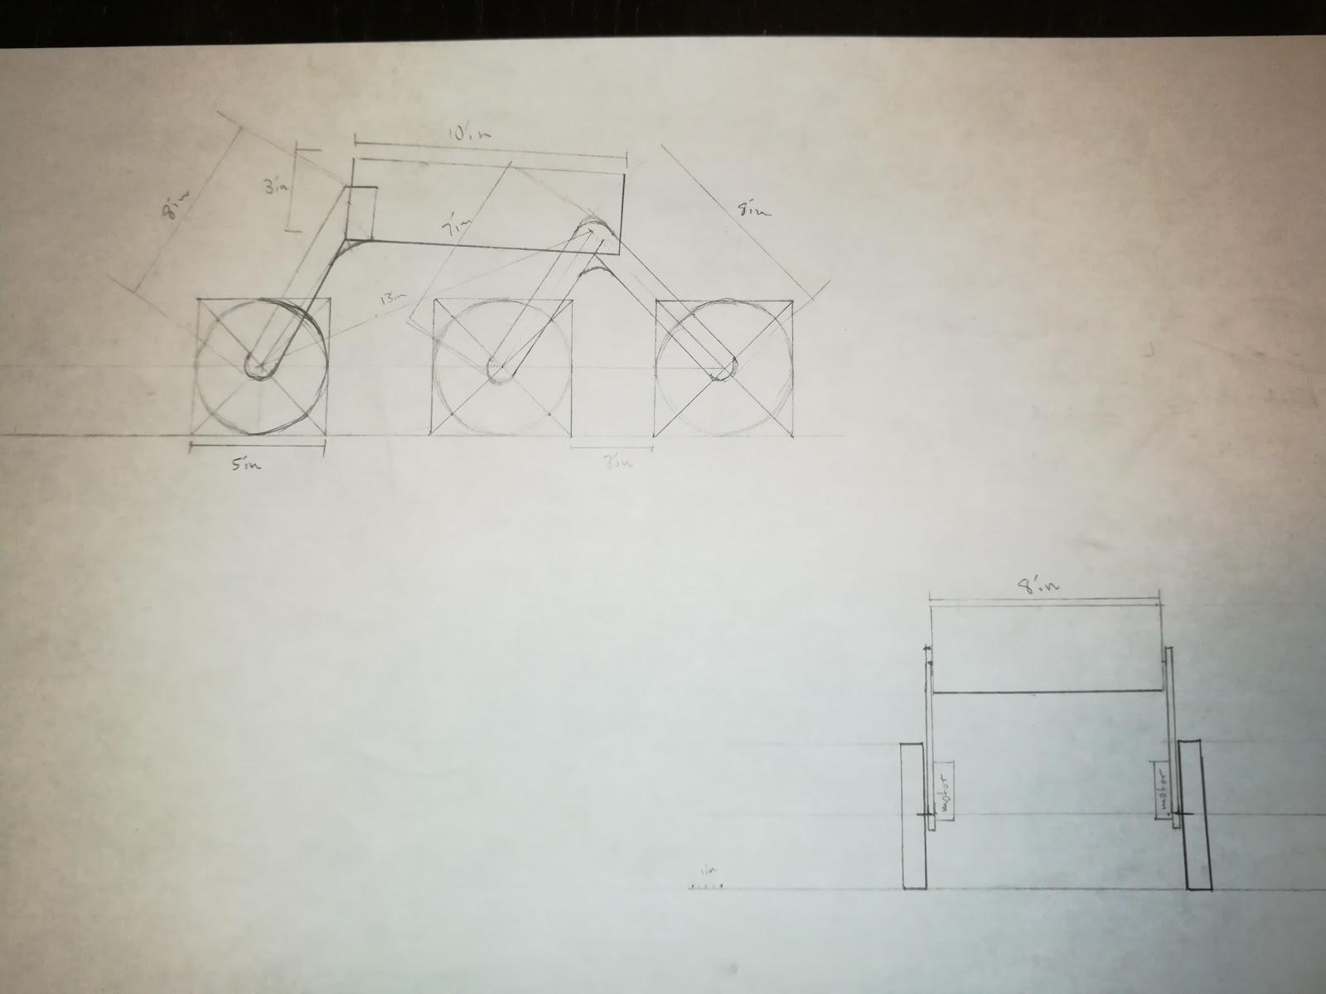

Figure 6: Preliminary Technical Drawing – 2

The robot will have a 6-wheel design with the forward two front wheels attached together to better climb stairs and the back wheel providing stable support. Each wheel will be of the same composition and size. The brackets that attach the chassis to the wheels will also include springs (Technical Drawing 1) which will allow controlled movement of the wheels. Each wheel will also have attached motors on the underside of the robot (Technical Drawing 2). The chassis is meant to be small and lightweight in order to store the battery, Arduino, Bluetooth module, and additional weight in a safe and enclosed manner.

### **Updated Bill of Materials**

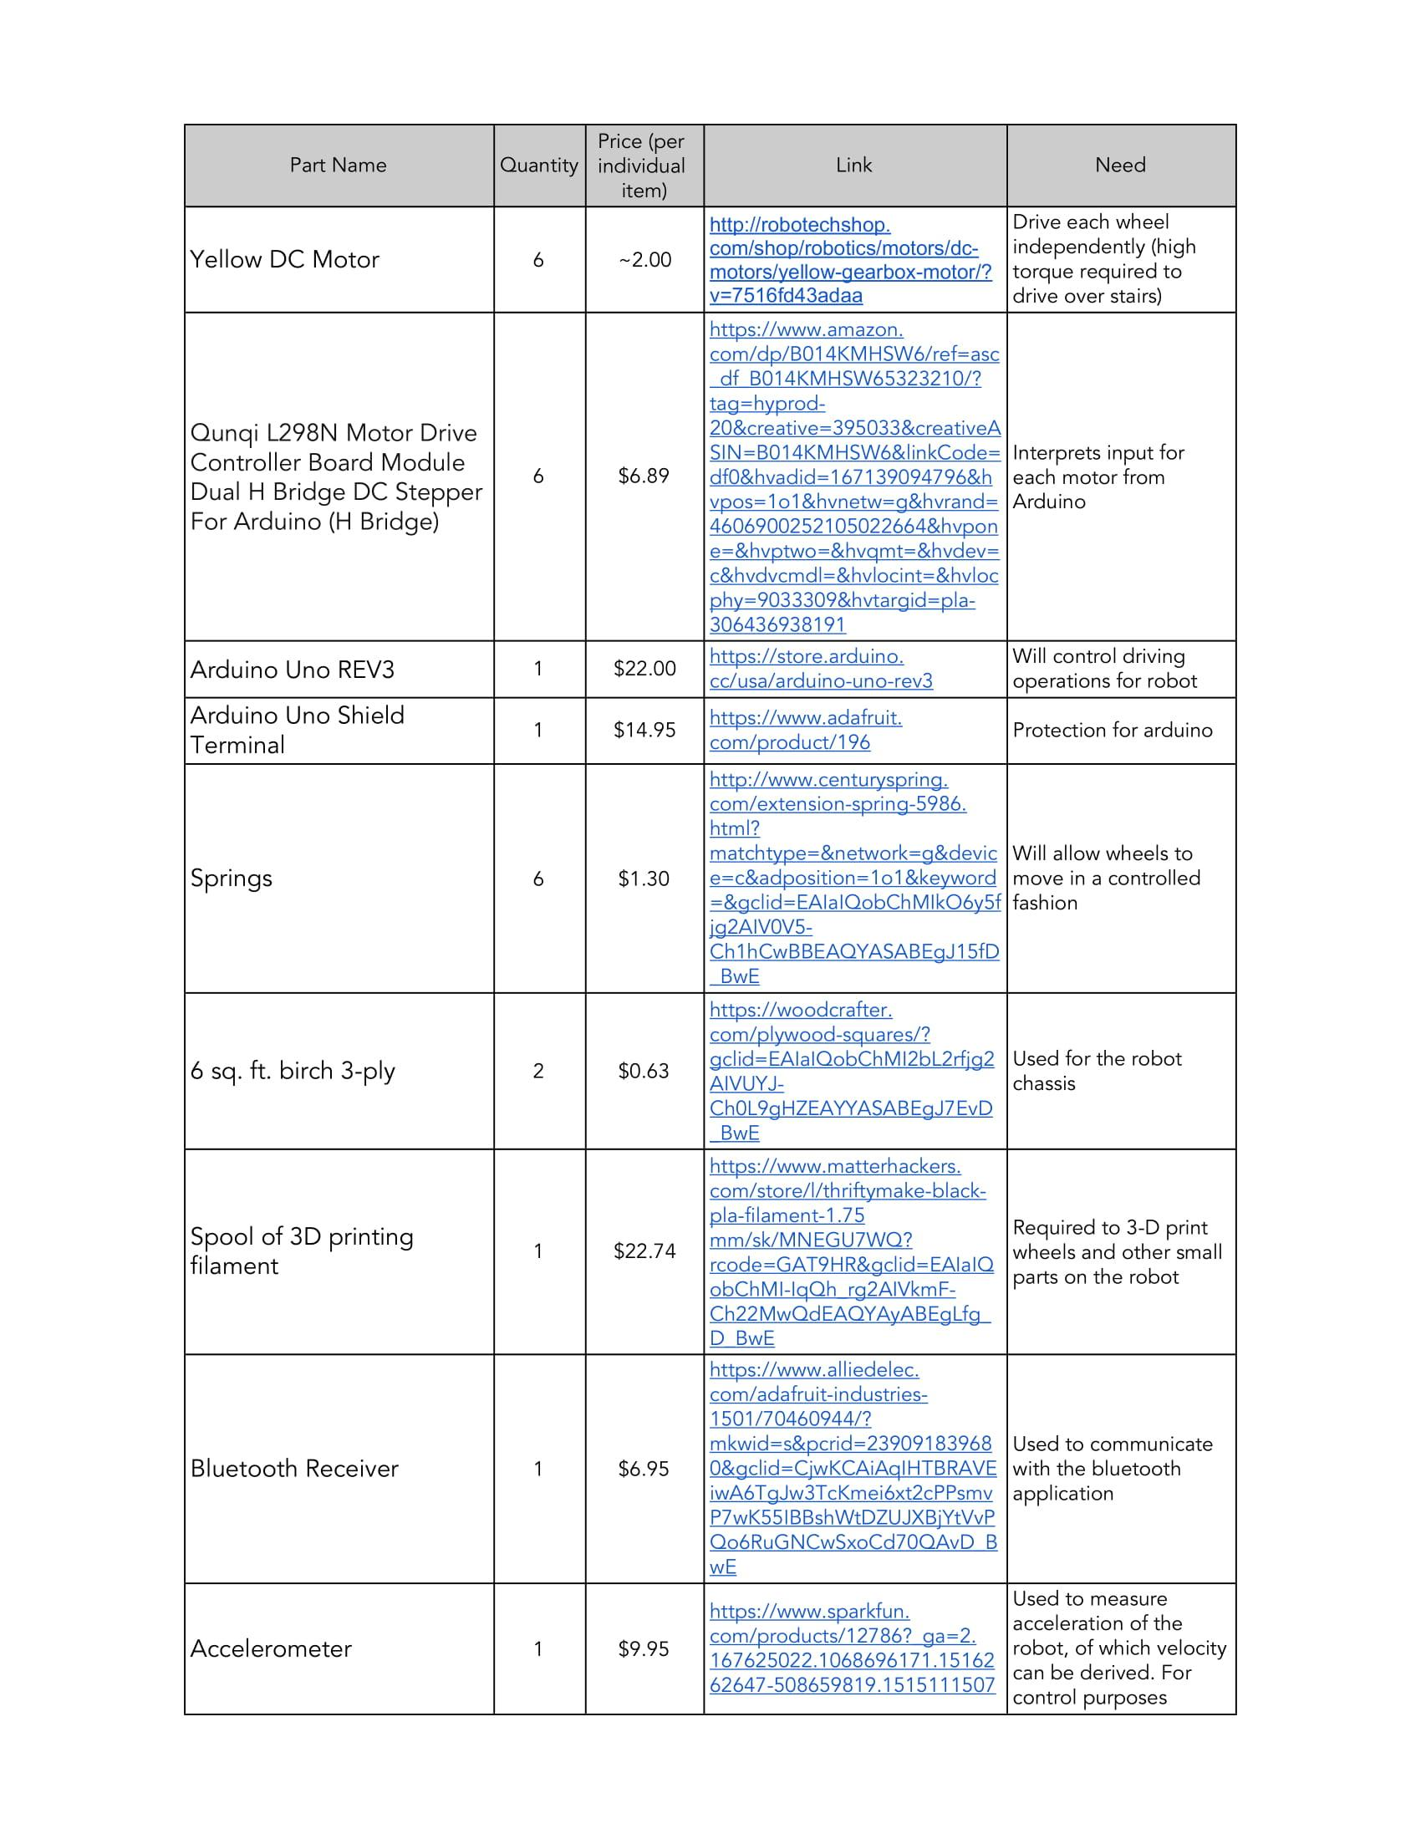

Table 1: Updated Bill of Materials Table

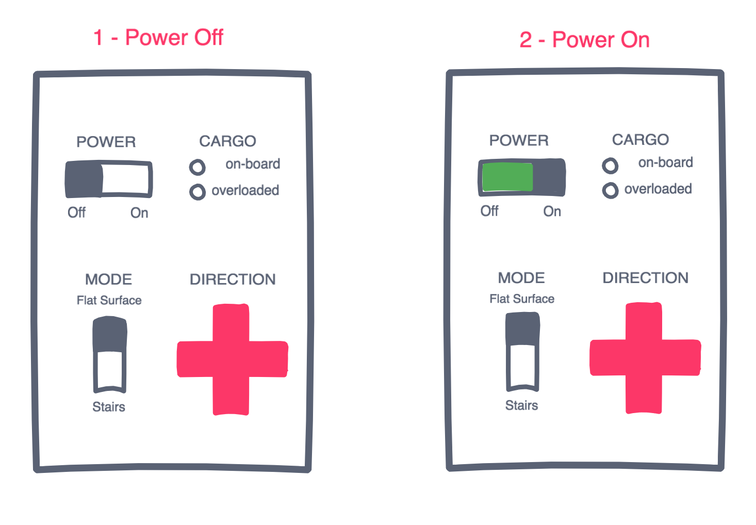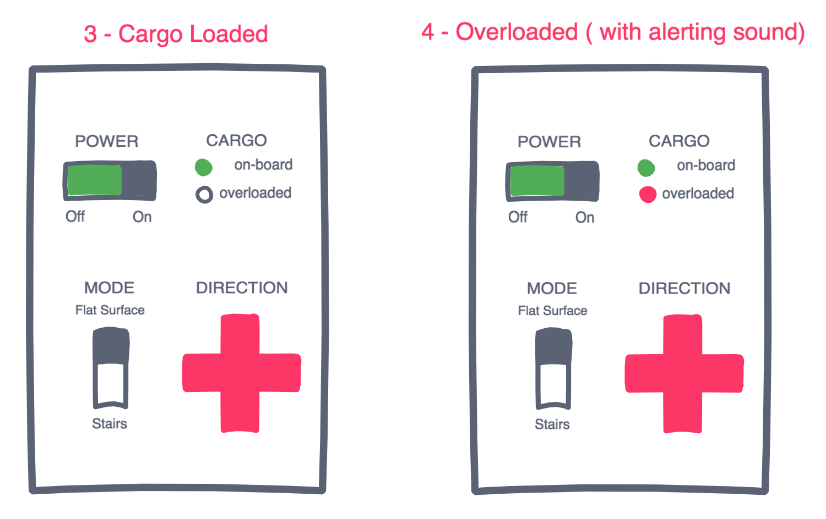

(see back)

